Website Traffic Analysis

## Introduction

Nowadays use of Internet is a part of nearly every day for private and occupational purposes by its users. In the virtual environment of Internet there exist a lot of Internet websites. Website content itself is very important for user. To find websites it is necessary to use some tools of internet marketing.

Internet offers quantity of tools to reach required information searched by user. From viewpoint of theory it is possible to classify this set of tools as a part of marketing communication mix. Schweiger a Schratternecker (2009) distinguish communication tools according to two criteria: „above the line“ and „below the line“. Approach „above the line“ includes all communication tools which should attract interested person impersonally or through mass communication. Approach „below the line“ copies personalized or individualized contents. Tool „below the line“ offers also direct possibility of contact with customers. Tool of on-line communication includes communication by Internet as well.

Marketing communication on Internet can have various forms considering various focused targets. According to defined aims the enterprise subsequently selects tools used to communication. The basic tools of Internet marketing are following:

* Advertising – it is tool for convincing and information people. It is used to induction of immediate interest in product and to creation of long-term relation with customer.
* Sales promotion - on Internet it can be focused on products marketed on-line in e-shops, but also in brick-and-

mortar store. In this case the Internet is communication medium above all and informs of certain activities for sales promotion.

* Public relations - marked as PR - are used on Internet, just as in classical marketing, especially to build firm and

brand awareness.

* Direct marketing – it represents direct communication with selected segment of customers through special offer with aim to gain the quickest feedback and simultaneously to build long-term relations with these customers.

Each of mentioned tools has specific form of application. The most frequent forms of Internet marketing realization with aim to find information searched by internet user are as follows: PPC (pay-per-click), PPA (pay-per- action), space advertising, records to catalogues, priority listings, SEO, viral marketing, advergaming, and participation in various social networks Madlenak, Svadlenka (2009).

## Target and methodology

Object of research described in this article is impact of selected tools of Internet marketing on website traffic.

The main goal of research is to monitor influence of Internet marketing selected tools application on official website traffic. For this research there were selected following tools and their monitoring: implementation of business website and personal website of the business website owner, where short blogs are published and use of social network Facebook.

The first confirmation is related to impact of personal website of the business website owner, where short reflections on various topics connected with business in form of blogs are published. In compliance with this the hypothesis H1 was set: Web traffic at the official business website is supposed to depend on web traffic at the personal website of the business website owner.

The second confirmation is related to impact of competition spread at social network Facebook. In compliance with this the hypothesis H2 was set: Web traffic at the official business website is supposed to depend on range of competition on users at social network Facebook.

To discover impacts of selected Internet marketing tools on website traffic, the real firm of providing e- commerce from Banska Bystrica region was chosen. This firm was object of research considering decisive assumption that it has not implemented tools of Internet marketing and offers possibility of website reengineering and comparison of web traffic before and after implementation of selected tools.

To monitor of web traffic and measurement of related data necessary to research solution, Google Analytics tool was used. It observes Internet users by finding of website, the way of its browsing, and it provides daily web traffic

overviews. As inputs for research of determined problems there were used data of daily web traffic number, number of website display, sources from which visitor reached website and key words entered to search engine.

Web traffic at social network Facebook was measured by Facebook Insights tool. This tool is available for websites liked at least by 30 people. Panel of overviews provides statistics related to number of people like website, number of people ranged by website, number of people talking about it and so on. Important figure was number of social network Facebook users having certain contribution in range.

To assessment of these primary figures there was applied correlation analysis. Correlation analysis is statistical method which examines existence or nonexistence of dependence between quantities, in case examines degree of intensity of this relation.

## Solutions and discussion

* 1. *Reengineering of website*

The most simple way to increase official website traffic is its reengineering by change of its design. This change was realized also by analysed official business website.

Original used website was not sufficiently well arranged due to bigger number of bookmarks, which do not fulfil their content and they were not filled by actual information. Bookmarks on web comprised Introduction, About us, Products, Services, Gallery, References, Partners and Contact. Opening website contained only presentation of pictures without text. So visitor was not able to find out which firm is it about.

Quality website is the basis for application of Internet marketing. By suggestion there was put emphasis above all on simple and transparent structure for quick and intuitive orientation of visitor with consider to target group maybe unskillful to use Internet. Innovated website was created for target group 20-65 years aged. Actualized website was activated 1.4. 2013 and was based primarily on firm logo colors. Menu was situated on horizontal level to be transparent and not meddle in body of page. Number of bookmarks was simultaneously reduced as well.

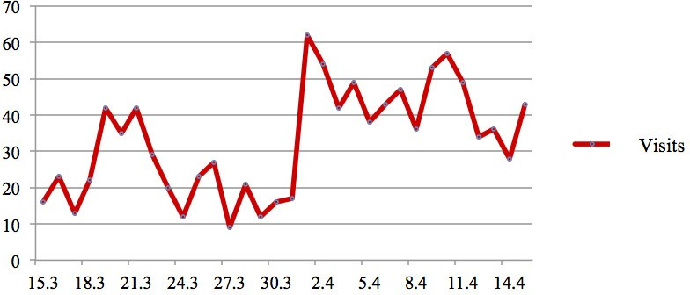

Fig. 1. Business website traffic

Indicator of website traffic is measured by Google Analytics tool which daily brought web traffic data. Analysis of web traffic reflects that average web traffic per day reached roughly 23 visits during last two weeks by use of original web. After starting of new websites the average web traffic per day increased nearly up to 45 visits per day during period since 1.4. till 15.4. 2013. It is evident that website traffic changed significantly after its reengineering.

* 1. *Creation of personal website*

Business owner decided to create personal website for writing of blogs on actual topics on e-business and e- commerce and other topics close to his interest in spare time. After starting of personal website the number of visits was surprisingly high. It reached up to 1000 visits per day on some days.

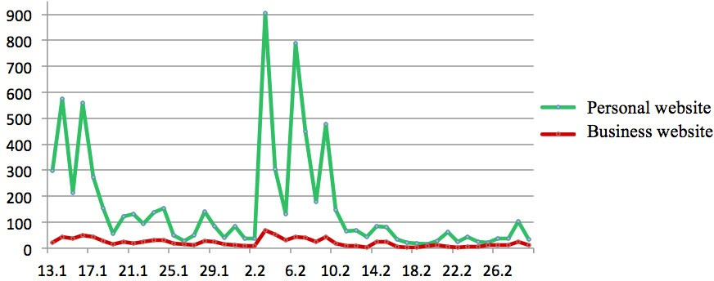

Fig. 2. Comparison of business website traffic and personal website traffic

On the basis of results following from business website traffic and personal website traffic of business owner there was made the measurement of correlation for both web traffic data. Pearson´s correlation coefficient was calculated in the following form:

1 n (x  *x*)  (y  *y*)

i

i

rX,Y 

*n* i1

# 1 n 1 n

*n*

(1)

 (x i i1

*n*

− *x*) 2 

⋅  (yi i1

− *y*) 2

where x is variable of personal website traffic and y is variable of business website traffic (1). Dependence between these two quantities was confirmed by calculated value of correlation coefficient 0.846 - it means positive correlation. Linear regression function of this dependence with determination index of 0.71601 has form as follows:

𝑦 ൌ ͲǤͲ͸͵͸ ή 𝑥 ൅ ͳͳǤ͵͹ʹ (2)

where *x* is variable of personal website traffic and *y* is variable of business website traffic. Calculation of both websites traffic correlation confirms that their traffic is mutually dependent. Hypothesis H1 set in introduction about dependence of business website traffic on personal website traffic of business owner was confirmed (2).

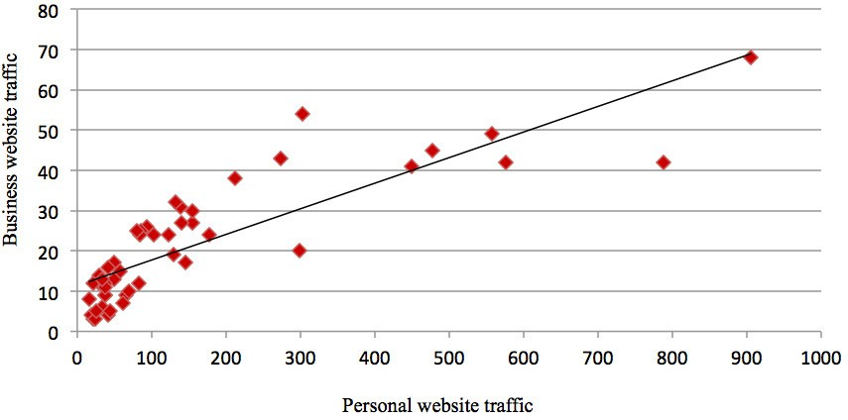

Fig. 3. Correlation of personal and business website traffic

* 1. *Competition spread by social media*

Analysed firm had created just in past times own business profile at social network Facebook. This social network was used with aim to create means for increase in web traffic and knowledge of business. Interconnection of business websites and business profile at social network were realized by use of Likebox object which shows also existence of business profile at social network Facebook to visitors of this business website. Likebox shows list of fans with liking to this website as well.

Generally it can be said that participation of firm at social network Facebook contributes to increase in visitors streams of official business website. During two-months monitored period increase in web traffic had numbered 25

% by visitors from environment of social network Facebook. The basis for this result was monitoring of data from Google analytics tool.

The next activity was use of social network Facebook to spread competition organized by analysed firm with aim to ensure higher number of business website visitors. To analyse efficiency of competition spread at social networks the figure of Internet users number was gained during monitored period. Related users saw information of competition at social network Facebook. These data were proceeded from Facebook Insights tool.

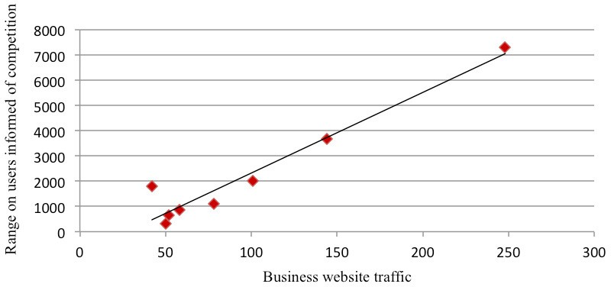

Fig. 4. Correlation of competition range at social network and business website traffic

To verify dependence between business website traffic and competition spread range on users able to see information of competition at Facebook, correlation analysis was applied again. Calculated correlation coefficient reached 0.96, it means that dependence between these two variables is significantly high. Linear regression function of this dependence with determination index of 0.93445 has form as follows:

Y = 31.928 * x – 870.84 (3)

where *x* is variable of business website traffic and *y* is variable of range on users informed of competition.

Hypothesis H2 about influence of information spread of competition at Facebook on business website traffic was confirmed by means of correlation analysis (3).

## Conclusion

Marketing needs environment for its successful realization. Internet represents environment where nowadays the most active marketing fights for customers realize. This place is available 24 hours daily 7 days per week, but it does not know anything else than we instruct it to do we need. It is only environment with immense potential for marketing. Internet marketing offers various tools for various types of fights for customer. One of these fights lies in activities to attract customer at business websites, it is so called primary conversion.

Increase in websites traffic does not need use of all Internet marketing tools but it is necessary to know purpose for selection of concrete tool and what is contained in each realized step. All web subjects want to have high web traffic of their official websites but it is necessary to put a question if hundred times as high daily web traffic will really multiply number of customers hundred times as well. It is unavoidable to realize also where we want to get visitor of website, what we want him to do and what is our aim like. Then potential of Internet marketing can be fully and effectively utilized.

Realized researches and following analysis comprised in this paper include identification of dependences between official website traffic and used tool of Internet marketing.

How to save 80% on advertising costs — case study of eBike manufacturer Delfast

The company

Delfast is a leading global eBike manufacturer, producing unique, eco-friendly electric bikes that are exceptional in their range, power, and speed. The company holds the Guinness World Record for greatest distance travelled by an eBike on a single charge — 228 miles.

Delfast is a Ukrainian–American company with dual headquarters in Kyiv, Ukraine, and Whittier, California. They develop and prototype eBikes in Ukraine, produce them in China, and complete final assembly in Los Angeles.

Delfast started as a courier service in Kyiv, Ukraine, in 2014. In 2017, the company decided to close its successful courier business and dedicate itself fully to eBike development, launching a successful Kickstarter campaign that officially started the era of Delfast Bikes.

Challenges & Goals

Delfast’s marketers wanted to understand which online campaigns were bringing them real profit and which were wasting their advertising budget. For this, they needed a report that combined digital analytics data with sales information from their CRM. The report needed to show which online campaigns were bringing in leads, deals, and completed orders, how much advertising budget was spent on these campaigns, and what revenue they generated.

The problem was that the company’s data was collected and stored in different systems: advertising expenses were stored in advertising services, user actions on the website were stored in Google Analytics, and user and sales information was stored in HubSpot. To build a report based on this data, Delfast marketers needed to check for errors and clean, standardize, group, and merge data into a single format. This needed to be done regularly as data was updated in order to always have a current picture.

Cleaning, normalizing, and testing the compatibility of data from different sources takes a lot of time if you do it from scratch and manually. To prepare reports, analysts need to create and maintain a cascade of interconnected SQL transformations. Later, this turns into a tangle of SQL queries and scripts, the debugging of which takes a lot of time but doesn't create additional value.

The Solution

Step 1. Using OWOX BI Pipeline, the company automatically collects data from all its sources in Google Big Query:

Information from Google Analytics

Raw data from the website

Expenses from advertising services

Customer data from the HubSpot CRM system

OWOX BI automatically converts the raw data into an analytics-ready format: unified tag formats, a single currency, no duplicates or anomalies, bot detection.

Step 2. OWOX BI Transformation automatically applies basic transformations to the collected data, such as sessionization, merging cost data, determining user type (new or returning), custom channel grouping, and many others. In addition, Delfast can create and apply their own transformations.

Step 3. Using OWOX BI Transformation, OWOX analysts created a data model for Delfast that takes into account necessary metrics and business features. Based on this data model, they built a data mart that is connected to Google Looker Studio.

This is what the data flow looks like:

Thanks to the data model, Delfast analysts and marketers have significantly reduced the time it takes to prepare other reports and dashboards. Now, when they need a report for ad-hoc analysis, they do not turn to raw data but to data that has already been cleaned, deduplicated, and contains the necessary business metrics.

Business Results for Delfast

As a result, Delfast received a nine-page smart dashboard that combines their online data (expenses, sessions, and users) with CRM data (contacts, deals, and closed deals).

Thanks to this dashboard, Delfast marketers identified campaigns that consumed the majority of the budget and brought online conversions but did not generate closed deals.

Delfast marketers then turned off these campaigns and were able to redistribute 80% of the released budget to other campaigns.